Name: Minh Binh Nguyen

PantherID: 002-46-4288

**Task 3 Report**

**a. Foundation**

**Define the following: Task, Pipelining, Shared Memory, Communications, Synchronization. (in your own words)**

**Task:** It’s a set of codes (instructions) that is ran by a processor. A parallel program has number of tasks running on number of processors.

**Pipeline:** It’s a process which it breaks a task down into steps that can be executed by different processors. It takes the inputs.

**Shared Memory:** It’s a programming model where the parallel tasks can directly address and access the same logical memory locations without knowing where the actual physical memory is.

**Communications:** It’s an event of parallel tasks perform data exchange. It has several methods.

**Synchronization:** It’s the coordination of parallel tasks in real time. It involves waiting by at least one task, then causes application’s clock time to increase.

**Classify parallel computers based on Flynn's taxonomy. Briefly describe every one of them.**

Single Instruction, Single Data (SISD): This is a non-parallel computer (oldest type of computer) where only one instruction stream is executed and only one data stream is used during any one clock cycle.

Single Instruction, Multiple Data (SIMD): This a type of parallel computer where all processors work on the same instruction, but each unit can use a different data element. Best for graphics/image processing.

Multiple Instruction, Single Data (MISD): This is a type of parallel computer where each processor can operate on the data independently using separate instruction streams., a single data stream is sent to the multiple processors.

Multiple Instruction, Multiple Data (MIMD): This is a type of parallel computer where every processor can work on a different instruction stream, with a different data stream. This is the current modern supercomputer.

**What are the Parallel Programming Models?**

They are shared memory (without threads), Threads, Distributed Memory / Message Passing, Data Parallel, Hybrid, Single Program Multiple Data, Multiple Program Multiple Data.

**List and briefly describe the types of Parallel Computer Memory Architectures. What type is used by OpenMP and why?**

Uniform Memory Access (UMA): Represented by Symmetric Multiprocessor machines with identical processors. Equally access to the memory with the same access times. Sometimes it’s called CC-UMA (Cache Coherent UMA) which means if a location in shared memory is updated by 1 processor, the others know about the update.

Non-Uniform Memory Access (NUMA): It’s often made by physically linking 2 or more SMP’s. One SMP can access the memory of the others. But the access memory time are not the same at all time. The memory access across link is slower. If cache coherency is kept, they may be called CC-NUMA.

OpenMP uses CC-NUMA, because this architecture supports multi-processor, and shared memory machines.

**Compare Shared Memory Model with Threads Model? (in your own words and show pictures)**

Shared Memory Model:

The machine memory was built physically across networked machines, but the user can see it as a single shared memory. In this model, the tasks use a common address space, which they can access asynchronously. It uses mechanisms such as locks/semaphores to control access to the share memory. This helps solve the contentions and avoid any race conditions or deadlocks. This model is the simplest parallel programming model. This model benefits the programmer so that the notion of the lack of data “ownership”, so the programmers don’t need to specify explicitly the communication of data between the tasks. All the tasks have the same access level to the shared memory. One disadvantage is that it’s hard to understand and manage the data locality. This model is used for stand-alone shared memory machines, native OS, compilers and/or hardware provide support for shared memory.

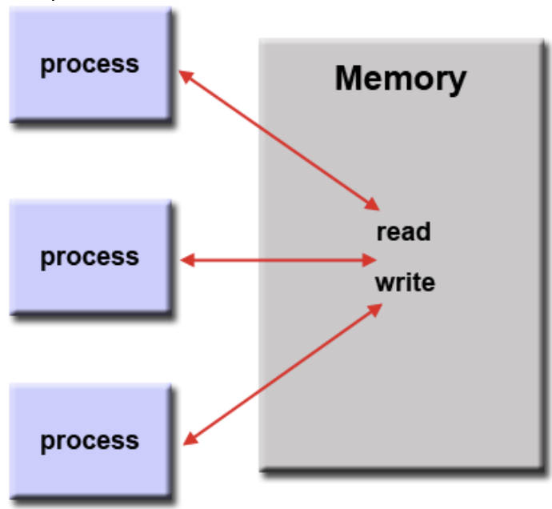

Threads Model:

This is a type of shared memory programming but in this model, a single “heavy weight” process can have multiple “light weight”, concurrent execution paths. The program is scheduled to be executed by the OS, the smaller tasks are then created after, and run by the OS concurrently. These threads share the local data and all the resources of the program. This model is implemented with a library of subroutines that are called from within parallel code, or a set of compiler directives imbedded in either serial or parallel code.

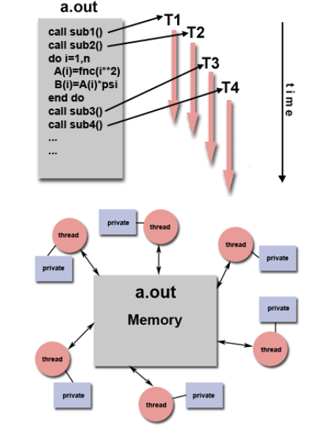

**What is Parallel Programming? (in your own words)**

It’s a technique where multiple compute resources are used simultaneously to solve a computation problem. In this type of computing, a problem is broken down into discrete parts that can be solved concurrently, these parts are further broken down into a set of instructions which can be executed simultaneously on different processors. An overall control mechanism is employed.

**What is system on chip (SoC)? Does Raspberry PI use system on SoC?**

SoC stands for system-on-a-chip. This integrates almost all of these components into a single silicon chip. It has a GPU, memory, USB controller, power management circuits, and wireless radios. The CPU cannot work without the other supporting components, but a single SoC can perform as a computer.

The Raspberry Pi uses SoC unit instead of having separate CPU, RAM, GPU.

**Explain what the advantages are of having a System on a Chip rather than separate CPU, GPU and RAM component.**

It benefits the devices using it by its size. It’s only a little bit larger than a CPU, so it has much shorter wiring and uses less power, and also cheaper.

**b. Parallel Programming Basics**

I started with getting my Pi connected to my computer and changing the working directory to a preferred folder named “Project” (Figure 1).

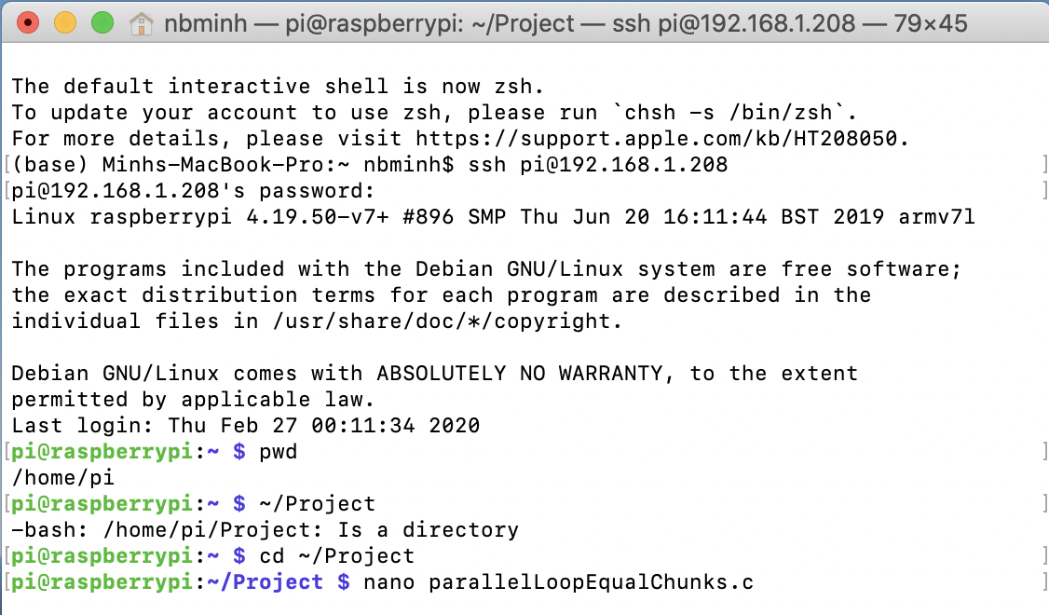

Figure 1

Then I typed in the code as instructed (Figure 2).

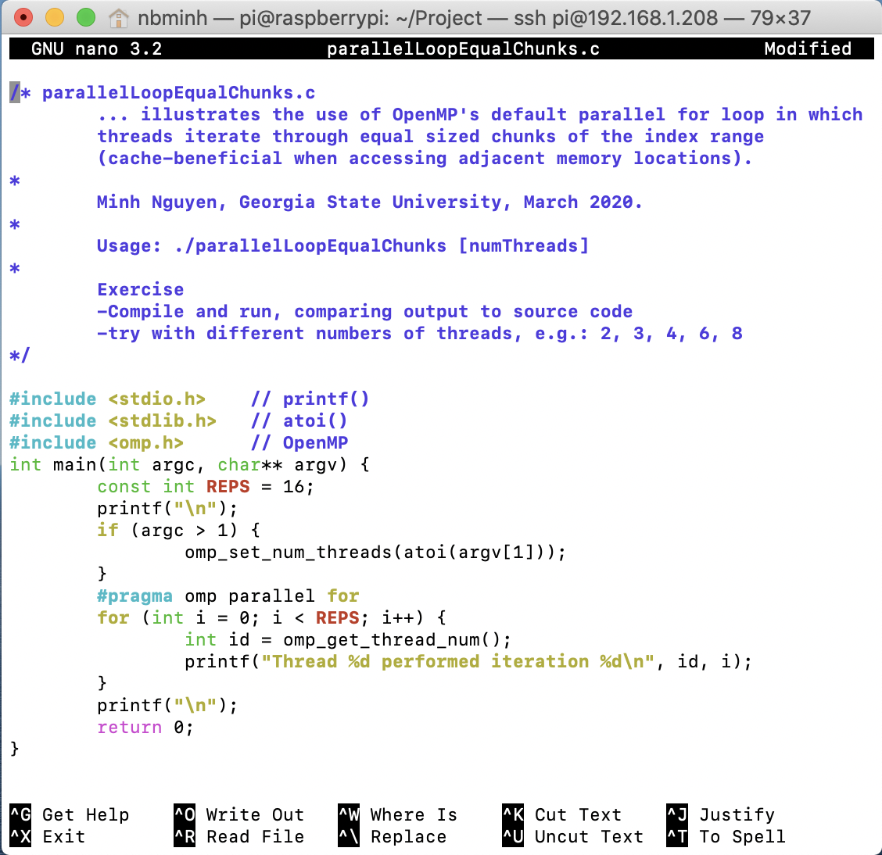

Figure 2

I then made an executable program and ran it with 4 threads (Figure 3).

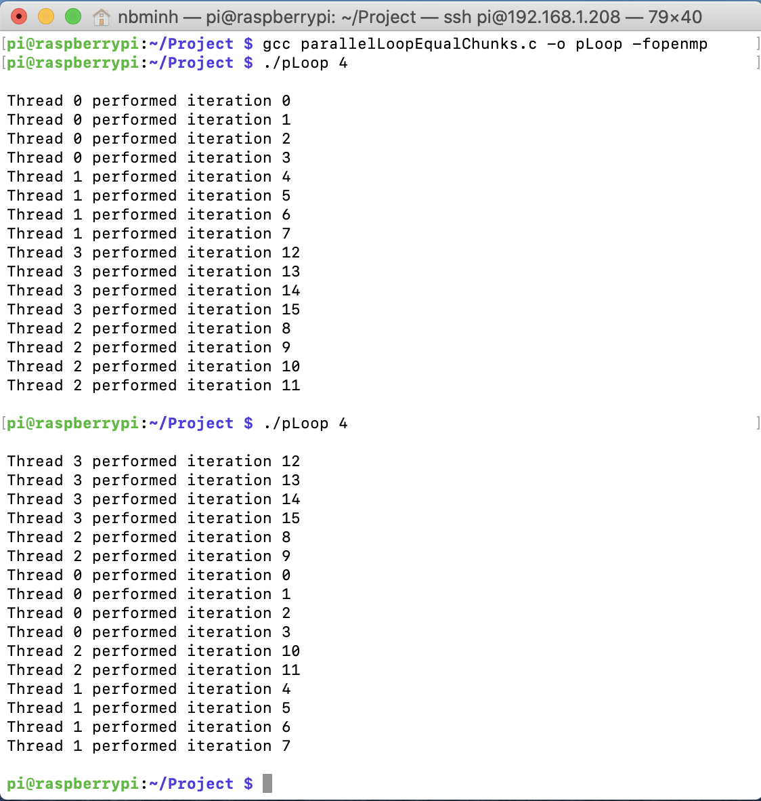

Figure 3

Notice that it runs with 4 threads by default if there is no argument passed in (Figure 4).

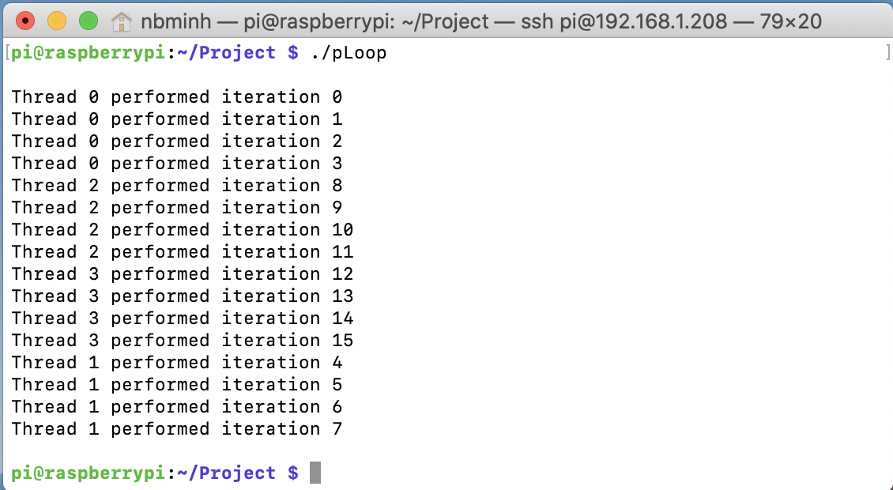

Figure 4

The pattern can be easily recognized. The iterations are divided evenly into the threads. Thread 0 takes the first 4 iterations (from 0 to 3), thread 1 takes the next 4 iterations (from 4 to 7), and so on.

I also ran it with 5 threads (Figure 5), 6 threads (Figure 6) to see how the program divide the work into the threads when the number of iterations is not evenly divisible by the number of threads.

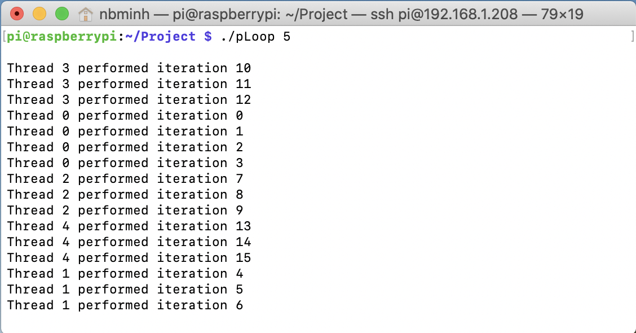

Figure 5

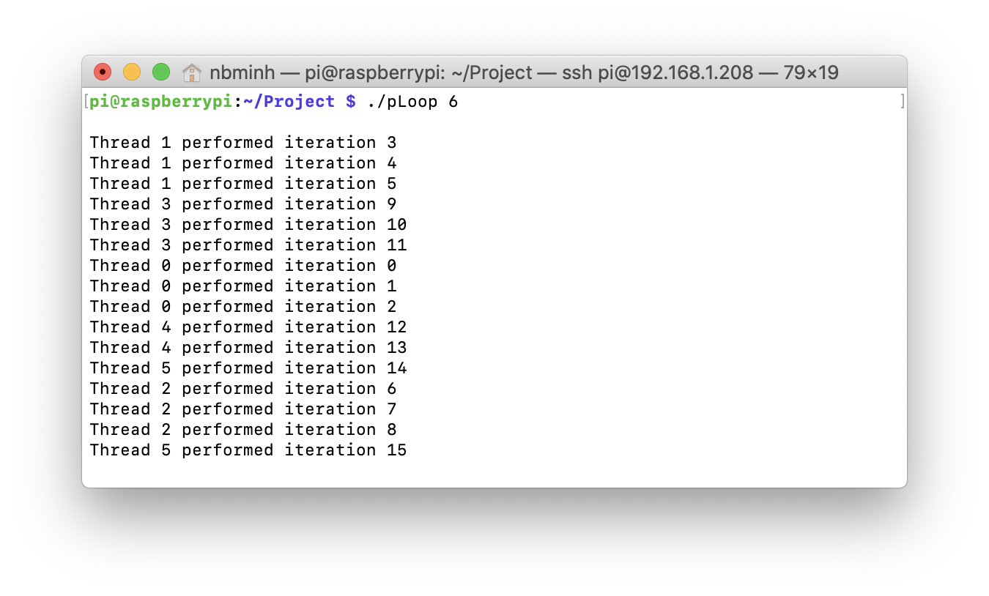

Figure 6

The pattern is still the same. Each thread is assigned with several consecutive iterations in order.

I created another file, then typed in the code for pLoop2 as instructed (Figure 7).

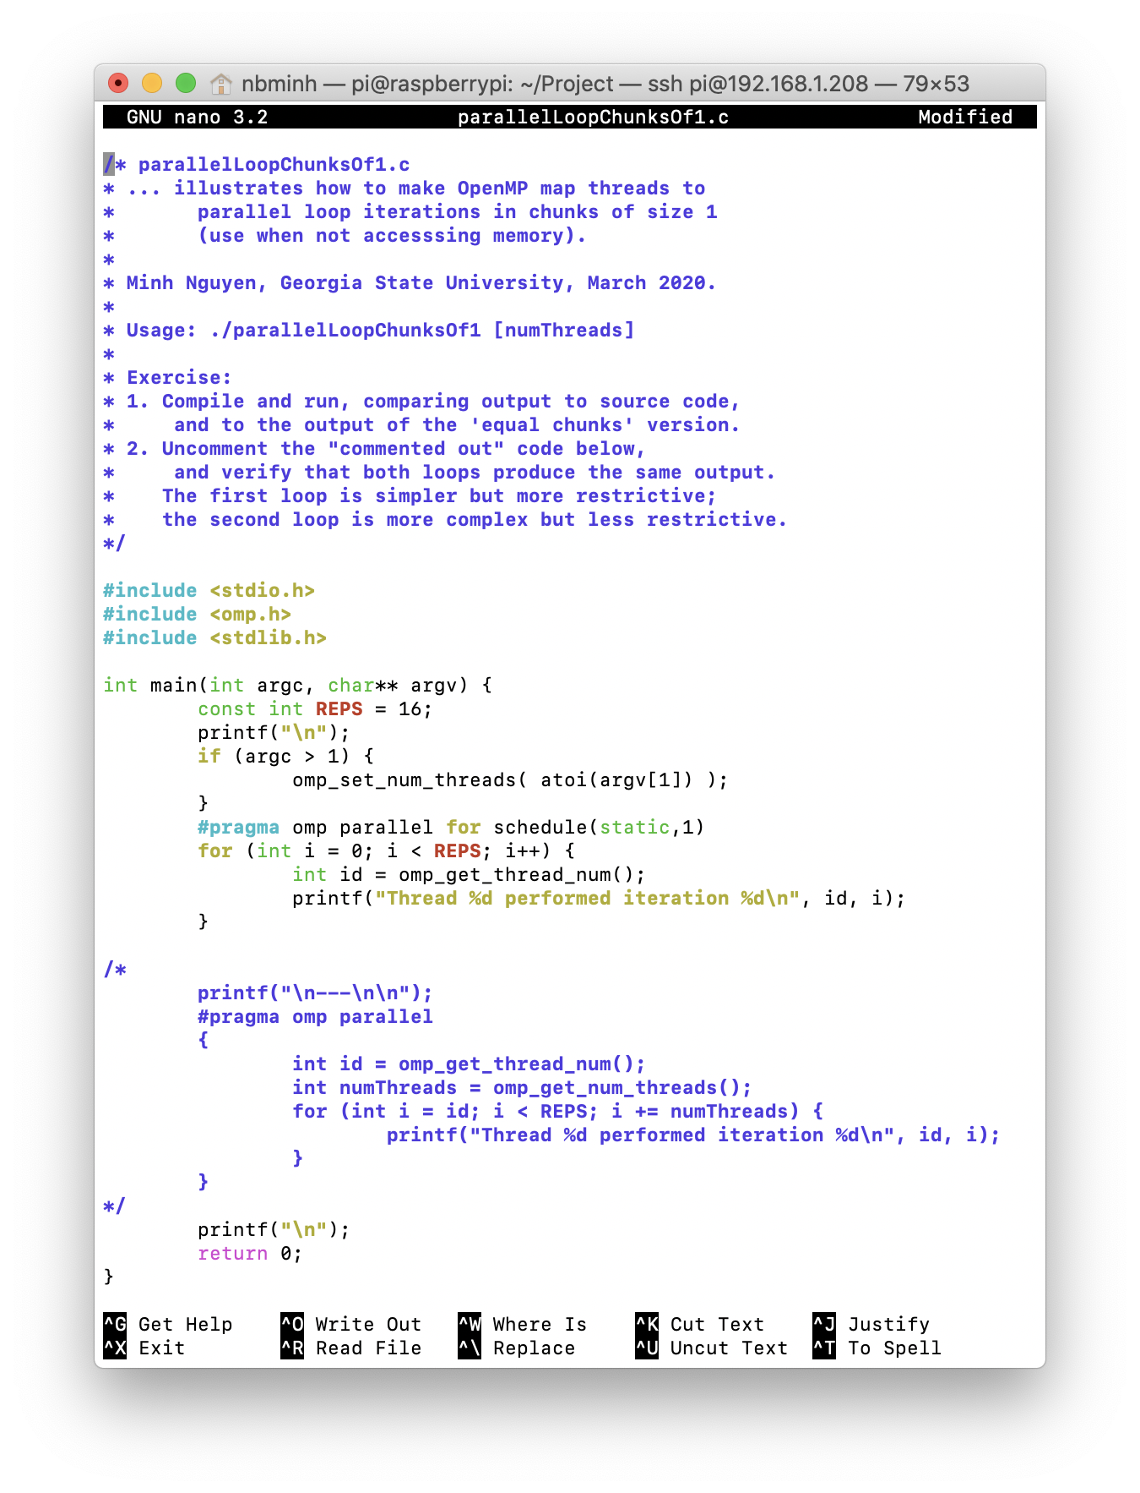

Figure 7

Then I made an executable program and ran it (Figure 8).

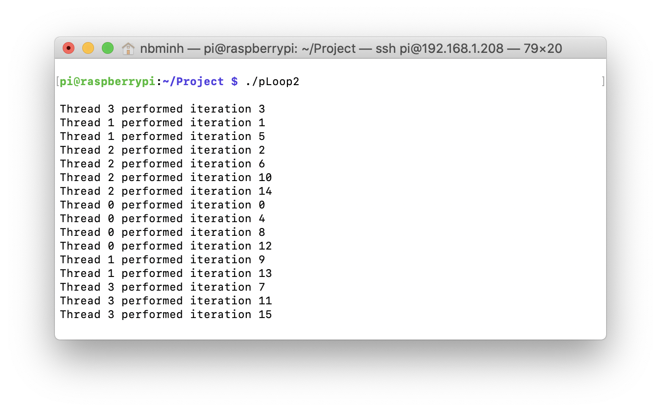

Figure 8

With 4 threads (by default), the iterations are assigned to the threads in order so that thread 0 gets the first iteration, thread 1 gets the next one, thread 2 gets the next one, thread 3 gets the next one, then the next one goes back to thread 0, and so on.

The same pattern can be found when running with different number of thread (Figure 9).

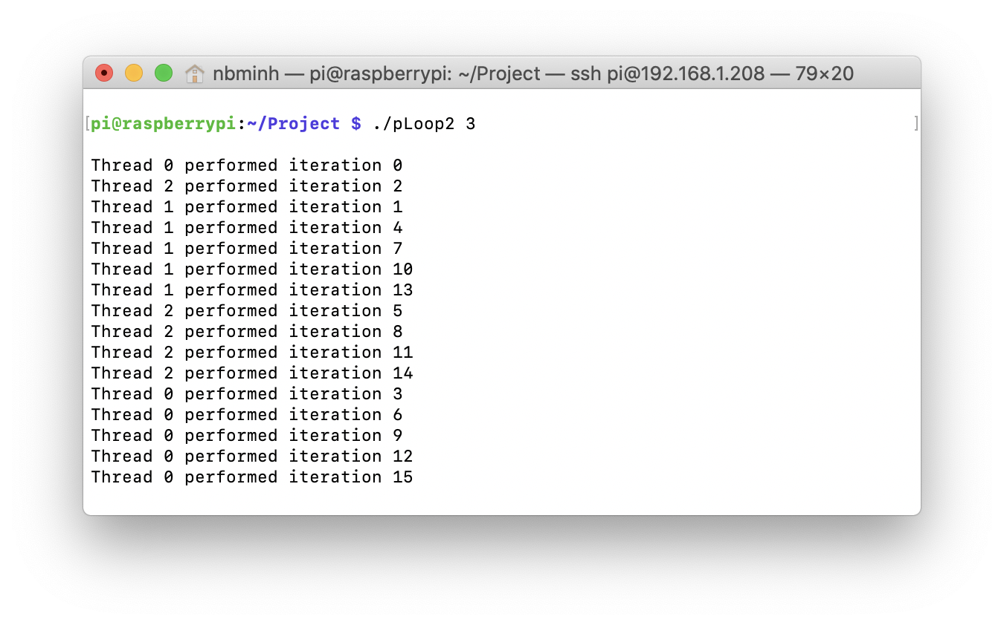

Figure 9

I then uncommented the code (Figure 10).

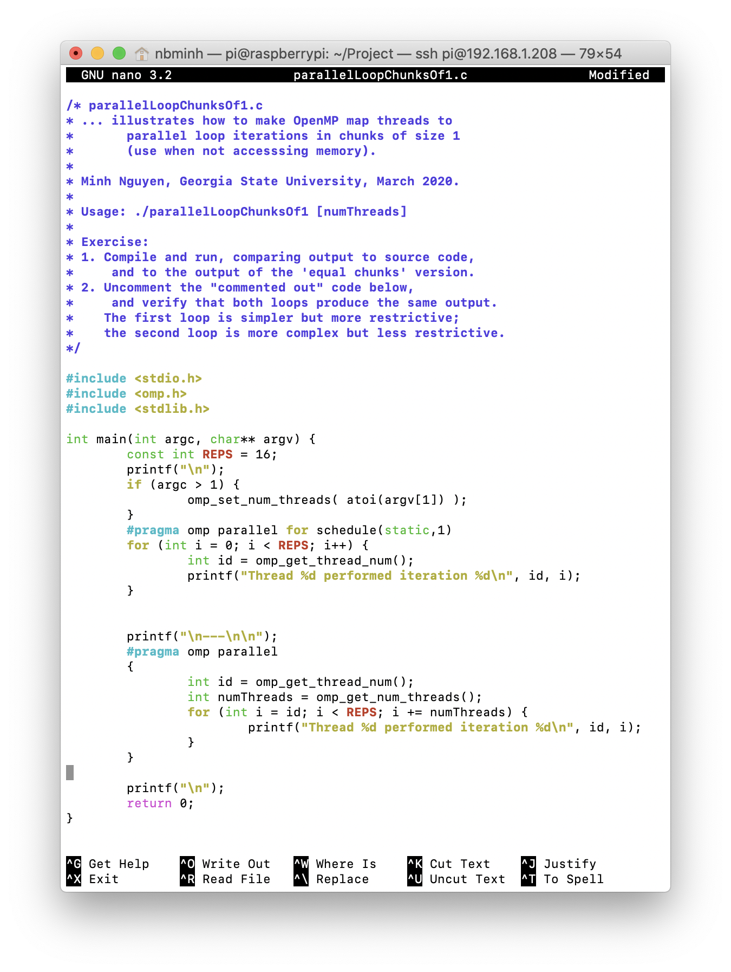

Figure 10

The two loops produce the same output. We still see the same pattern in 2 outputs (Figure 11 and figure 12).

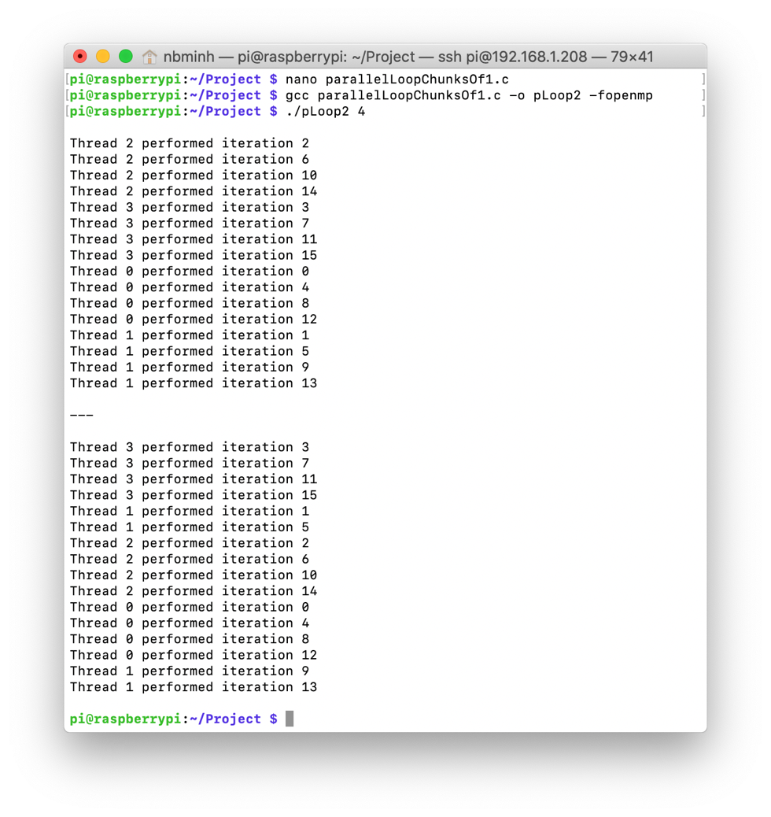

Figure 11

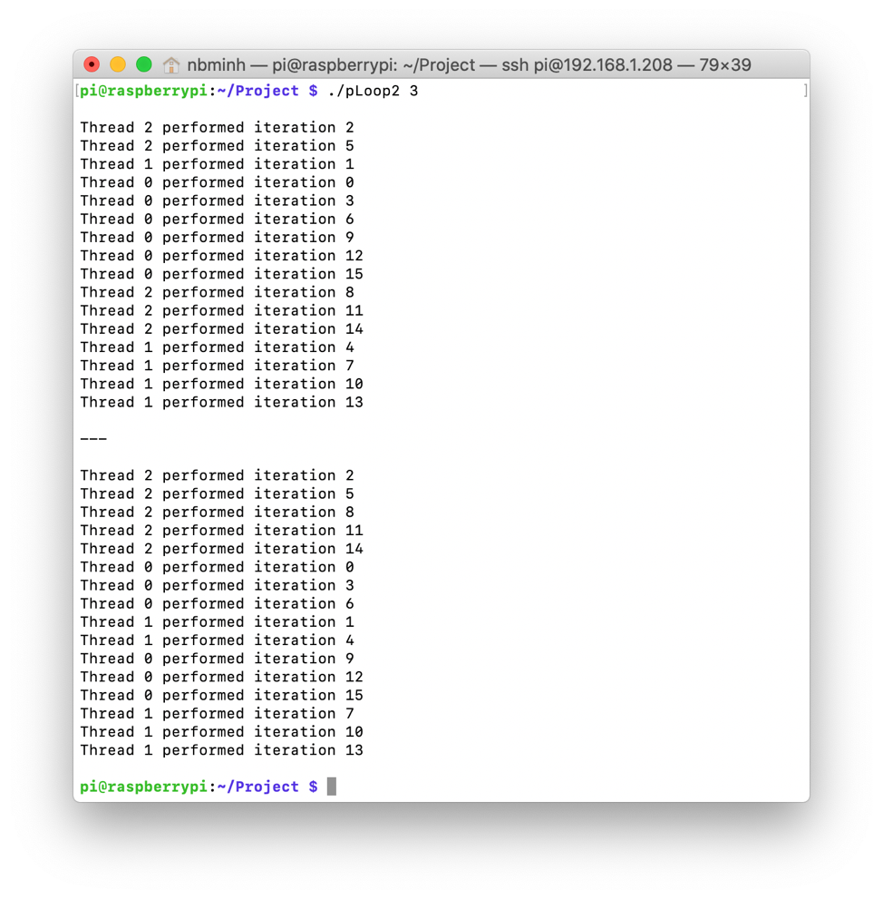

Figure 12

As moving into the next part, I typed in the program as instructed (Figure 13 and 14).

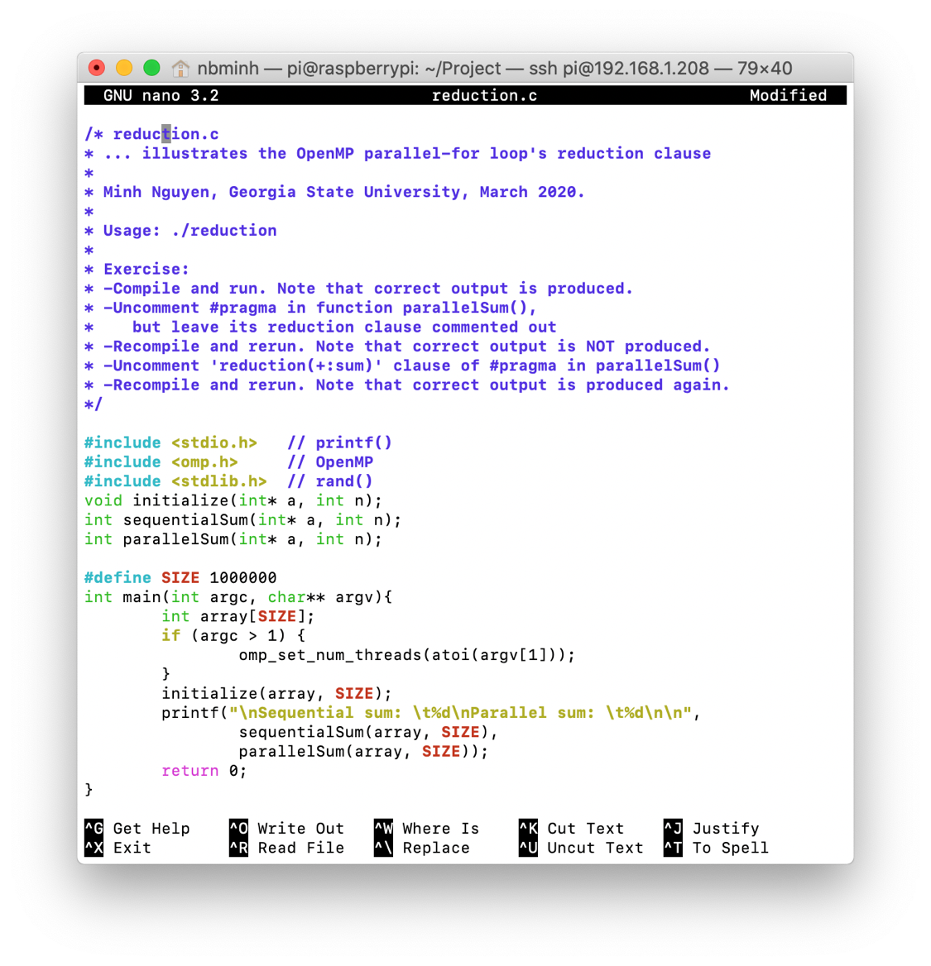

Figure 13

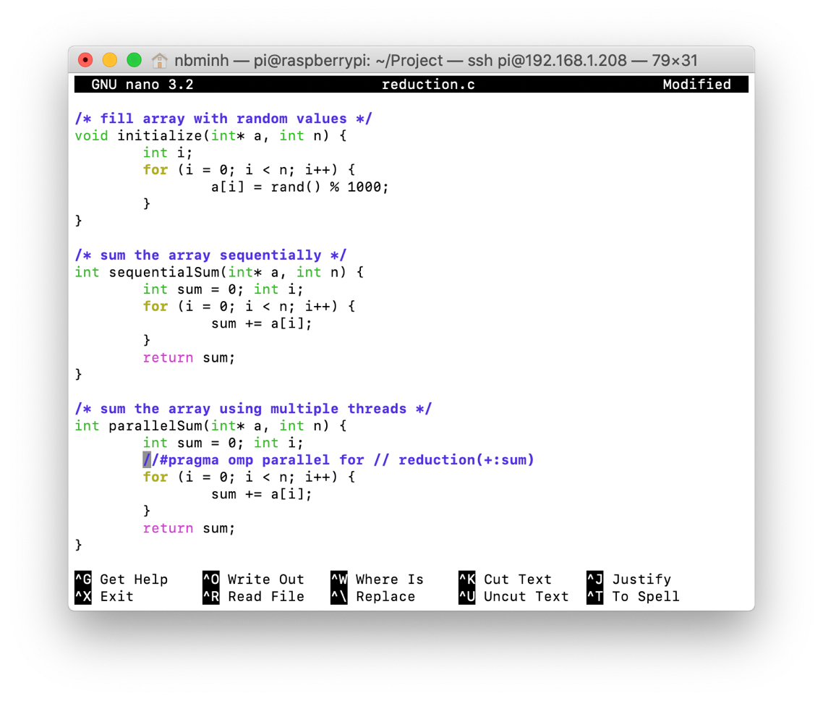

Figure 14

Before uncommenting the “#pragma” part, the identical results are expected because the codes are the same (Figure 15).

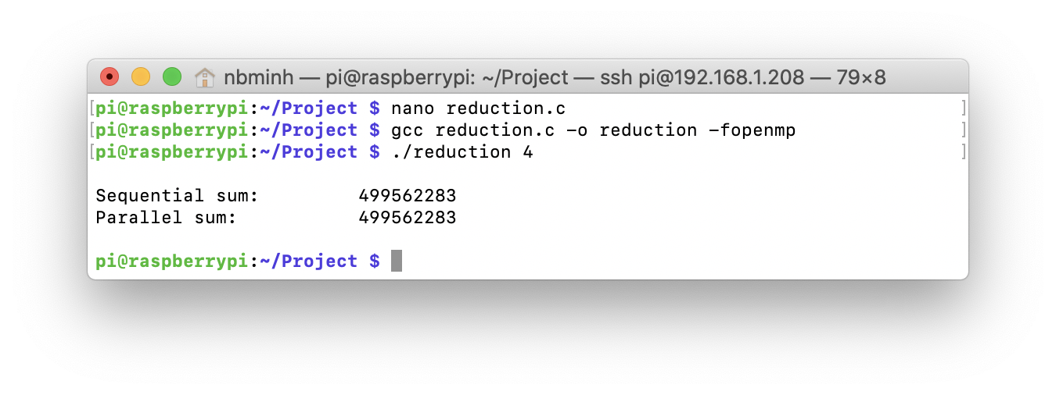

Figure 15

After uncommenting the “#pragma” part (but still keep the “reduction” part commented), the result of the parallelSum is incorrect (Figure 16).

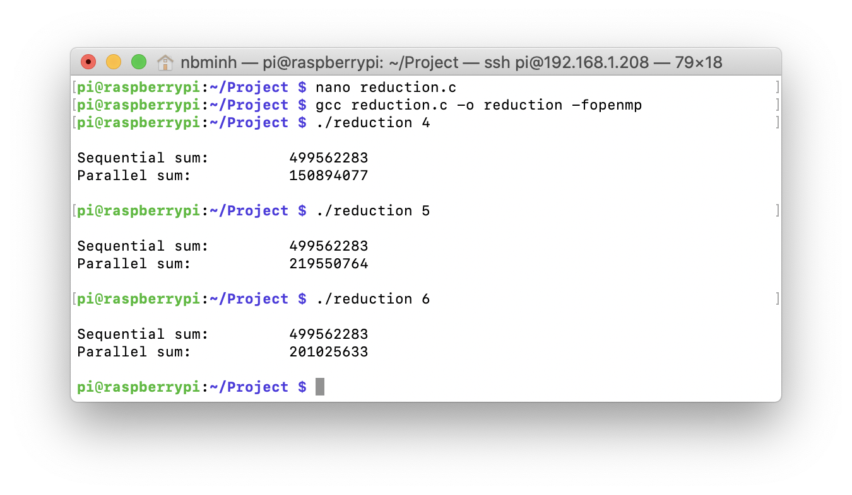

Figure 16

After uncommenting everything, the function works as it should (Figure 17).

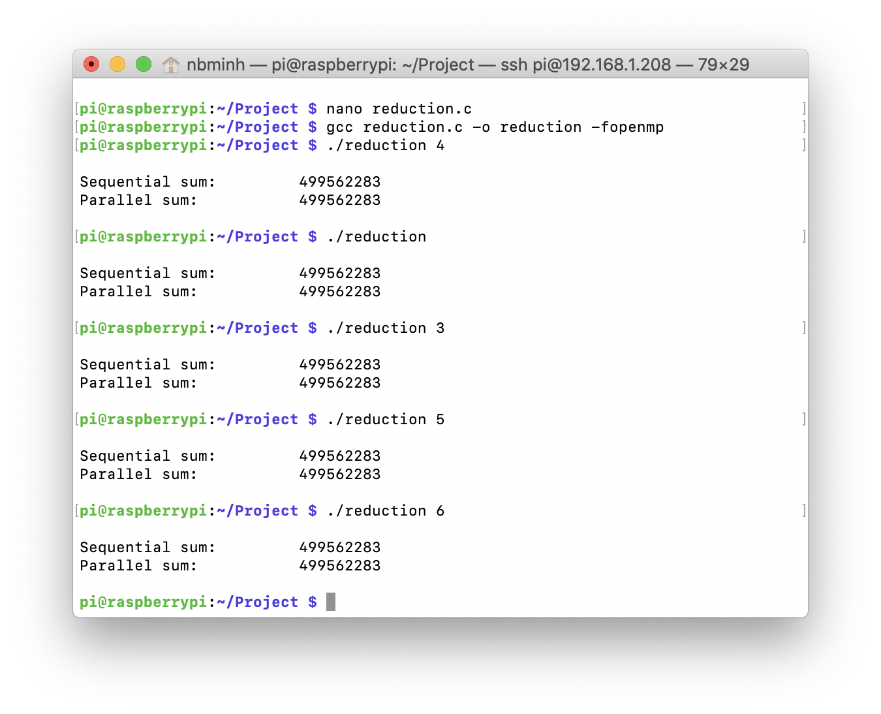

Figure 17

This is because without the reduction, the sum variable doesn’t depend on what all the threads are doing. When we put in the reduction clause, this variable is private to each thread.